# **RADxUP – Take Care, Texas Program**

# **Citi Human Subjects Training – Instructions**

All researchers and research staff involved in conducting research with human subjects must complete CITI Human Subjects training every 3 years. Since Health in My Hands requests personal information during eligibility and the baseline and follow-up survey – which are evaluations – all those staff members involved in the program, at any level, must complete this CITI certification in order to comply with UTHealth’s Institutional Review Board’s protocols.

**STEP 1 – Log on to CITI** www.citiprogram.org and click on **Register**

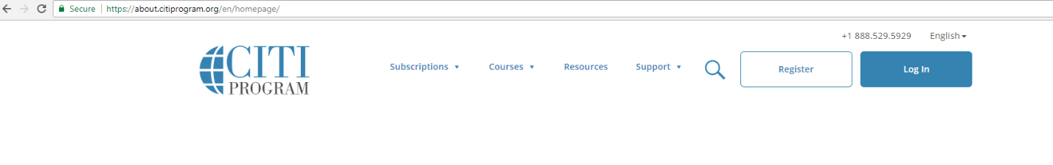

**STEP 2 – SELECT YOUR INSTITUTION OR ORGANIZATION**

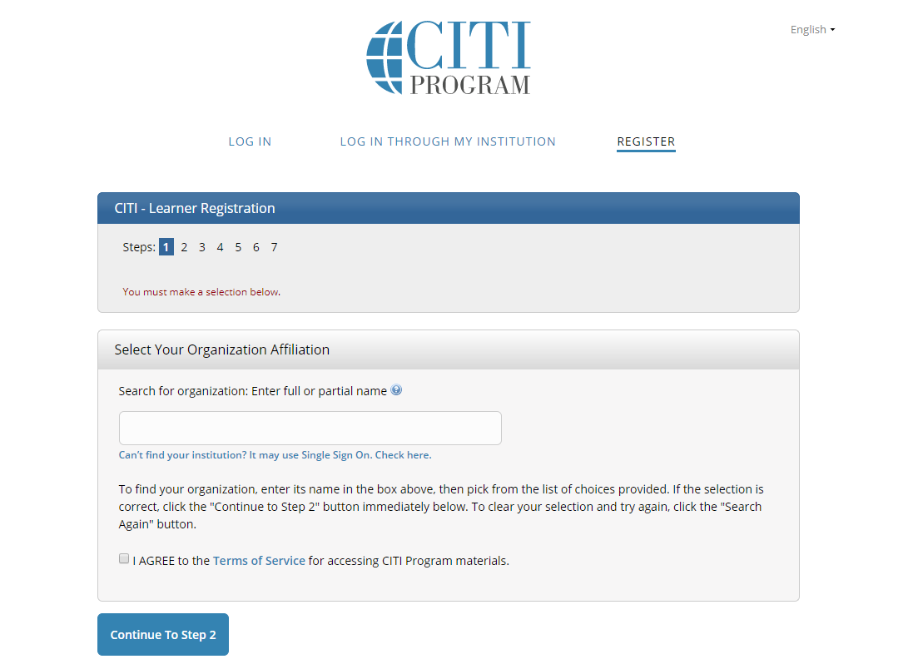

University of Texas Health Science Center at Houston

Check the “I AGREE” box.

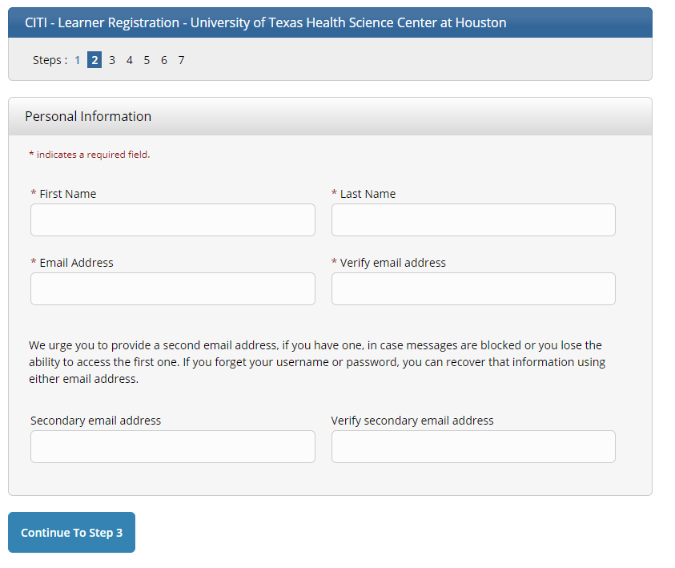**STEP 3 – PROVIDE PERSONAL INFORMATION**

In, "Email Address" enter your UT email. You may also choose to enter a "secondary email."

**STEP 4 – CREATE YOUR USERNAME AND PASSWORD**

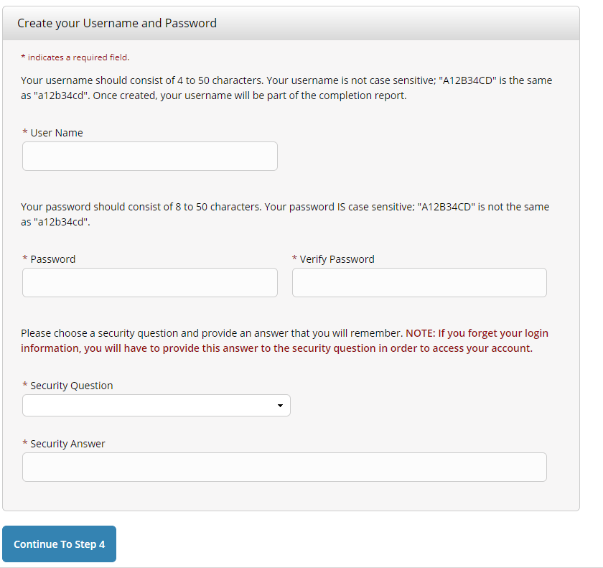

**STEP 5- SELECT COUNTRY OF RESIDENCE:** Write United States

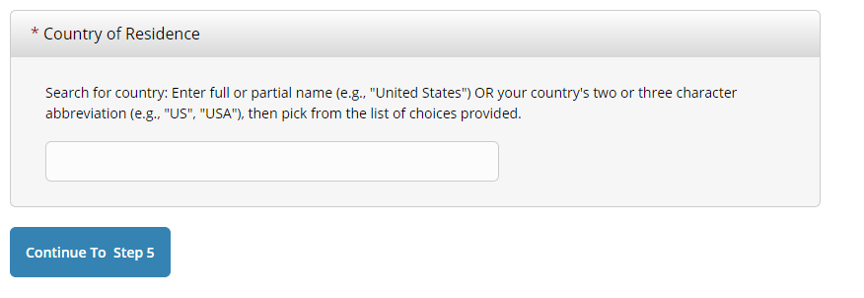

United States

**STEP 6 - CME/CEU CREDITS**

Here you are given the option to **pay** to receive credit or not and enter professional affiliation if credit is desired – note that Health in My Hands and UTHealth do not cover this cost, and you will have to cover it personally, if you would like the credits. If you do not wish to pay, select “no”

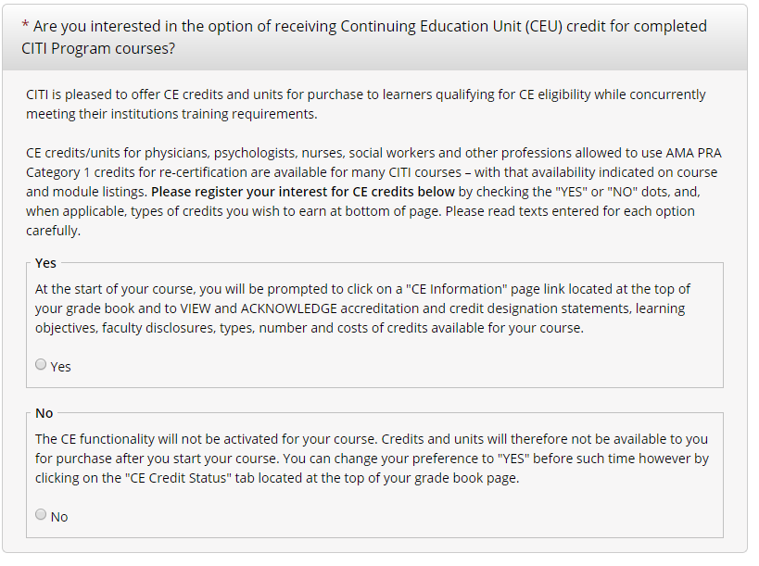

**STEP 7 - CME/CEU CREDITS –** select if you would like to get contacted by CITI in the future to fill out a survey or to receive marketing information

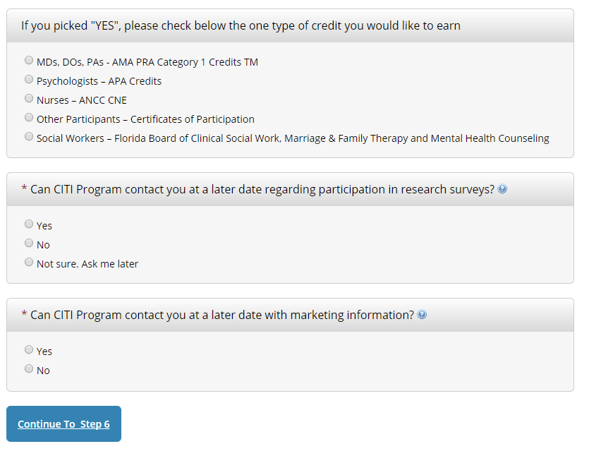

**STEP 8 – REQUESTED INFORMATION FROM UTHEALTH:** provide the info with an asterisk: email (your UTHealth address), highest degree (place your education level), employee ID (any number, if you don’t have an ID), role (recruiter), office phone number (place (713)500-9608). You may provide the rest of the info (it’s not mandatory).

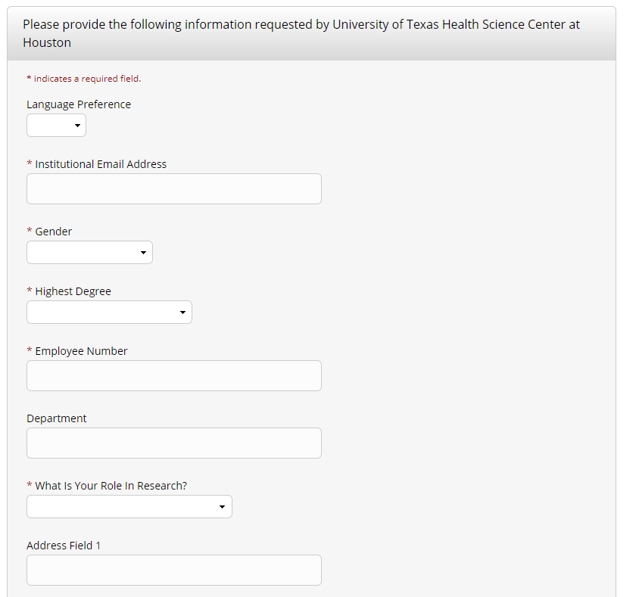

Choose: “Recruiter “

You DO NOT need to enter an employee number- enter “1234”

**STEP 9 - SELECT CURRICULUM - UNIVERSITY OF TEXAS HEALTH SCIENCE CENTER**

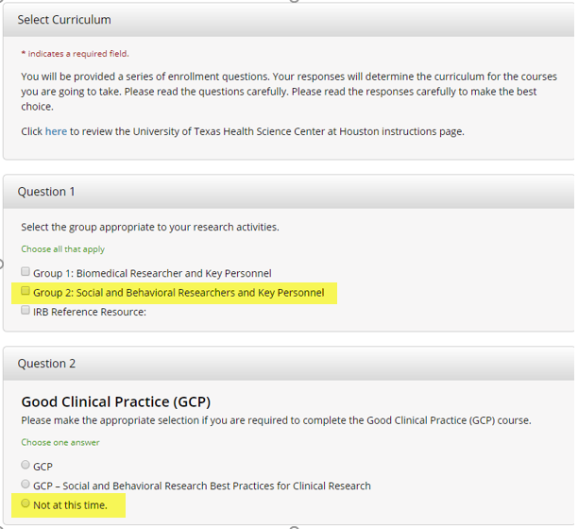

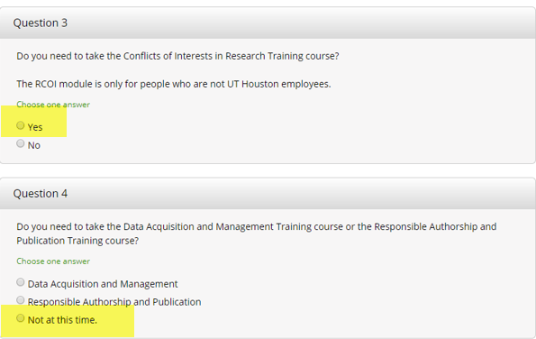

**Please note: Do not complete question 5**

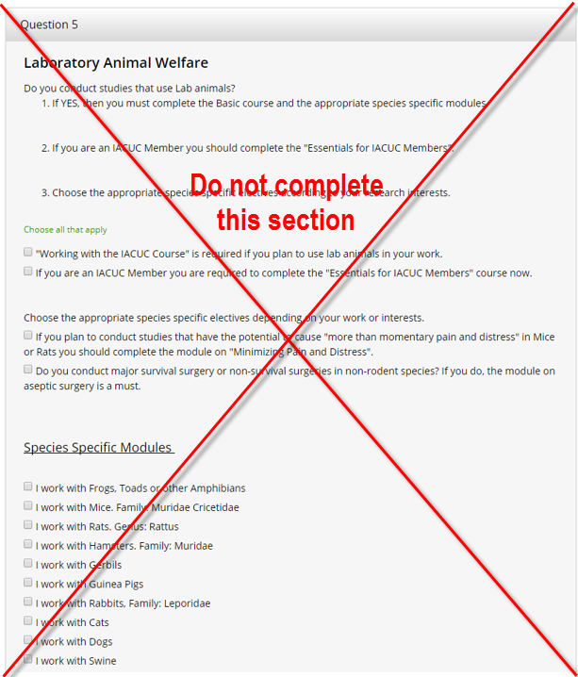

**STEP 10: TAKE COURSES** - You will now see the screen of selected courses.  Click on the word "ENTER" next to a course to begin the modules. You may stop at any time during the modules and your work to that point should be saved.

**ONCE COMPLETE**, please send your completed CITI certificate to Ibette Cavazos, Ibette.Cavazos@uth.tmc.edu

**Please note:** You will be prompted to take a refresher version of the Basic Course, and if applicable, GCP, every 3 years.